**EXPERIMENT NO: - 05**

Name:- Akruti Dabas Class:- D15A Roll:No: - 11

**AIM:**

To apply navigation, routing and gestures in Flutter App.

**THEORY:**

In Flutter, the screens and pages are known as routes, and these routes are just a widget. In Android, a route is similar to an Activity.

In any mobile app, navigating to different pages defines the workflow of the application, and the way to handle the navigation is known as routing. Flutter provides a basic routing class MaterialPageRoute and two methods Navigator.push() and Navigator.pop() that shows how to navigate between two routes. The following steps are required to start navigation in your application.

Gestures enable the app to respond to user interactions, making the application more dynamic and responsive.

**➢ Navigation and Routing in Flutter**

Navigation is the process of moving between different screens or pages in an app. Flutter provides a simple and effective way to handle this through the use of the Navigator widget and routes.

1. Using Navigator Widget

The Navigator widget manages a stack of routes, allowing for pushing and popping routes on the stack.

• Pushing a Route: To navigate to a new screen, use Navigator.push().

• Popping a Route: To go back to the previous screen, use

Navigator.pop(). ElevatedButton(

onPressed: () {

Navigator.push(context, MaterialPageRoute(builder: (context) => SecondScreen()),

);

},

);

2. Named Routes Flutter also allows the use of named routes to navigate, which can make the routing process cleaner, especially in larger applications. MaterialApp( initialRoute: '/', routes: { '/': (context) => HomeScreen(), '/second': (context) => SecondScreen(), }, ); Navigate to the route using Navigator.pushNamed() Navigator.pushNamed(context, '/second');

Handling Gestures in Flutter

Gestures refer to user interactions with the app, such as taps, swipes, pinches, and drags. Flutter provides several widgets and gesture detectors to handle these interactions.

Tap Gestures

The most common gesture is the tap, which can be handled using the GestureDetector widget or specific buttons like InkWell or ElevatedButton.

Long Press Gesture

For long press gestures, Flutter provides the onLongPress callback in GestureDetector or InkWell.

Swipe and Drag Gestures

Flutter also provides swipe and drag gesture handling. The onHorizontalDragUpdate and onVerticalDragUpdate callbacks are used for dragging gestures.

**CODE:**

**PROFILE_SCREEN.DART**

import 'package:feverr_clone/screens/inspiration_screen.dart';

import 'package:flutter/material.dart';

class ProfileScreen extends StatelessWidget {

  const ProfileScreen({Key? key}) : super(key: key);

  @override

  Widget build(BuildContext context) {

    return Scaffold(

      backgroundColor: Colors.black,

      appBar: AppBar(

        backgroundColor: Colors.green,

        title: const Text('Profile'),

        centerTitle: true,

        actions: const [

          Padding(

            padding: EdgeInsets.only(right: 16.0),

            child: Icon(Icons.notifications_none, color: Colors.white),

          ),

        ],

      ),

      body: Column(

        children: [

          Container(

            color: Colors.green,

            padding: const EdgeInsets.all(16.0),

            child: Row(

              children: [

                CircleAvatar(

                  backgroundColor: Colors.blue[100],

                  radius: 30,

                  child: const Text(

                    'A',

                    style: TextStyle(fontSize: 24, fontWeight: FontWeight.bold),

                  ),

                ),

                const SizedBox(width: 16),

                const Text(

                  'Akrutidabas',

                  style: TextStyle(

                    color: Colors.white,

                    fontSize: 18,

                    fontWeight: FontWeight.bold,

                  ),

                ),

              ],

            ),

          ),

          Expanded(

            child: Container(

              color: Colors.grey[900],

              child: ListView(

                children: [

                  ListTile(

                    leading: Icon(Icons.diamond_outlined, color: Colors.white),

                    title: Text('Get inspired',

                        style: TextStyle(color: Colors.white)),

                    trailing: Icon(Icons.chevron_right, color: Colors.white),

                    onTap: () {

                      Navigator.push(

                        context,

                        MaterialPageRoute(

                          builder: (context) => const InspirationScreen(),

                        ),

                      );

                    },

                  ),

                  Divider(color: Colors.grey),

                  ListTile(

                    leading: Icon(Icons.favorite_border, color: Colors.white),

                    title: Text('Saved lists',

                        style: TextStyle(color: Colors.white)),

                    trailing: Icon(Icons.chevron_right, color: Colors.white),

                  ),

                  Divider(color: Colors.grey),

                  ListTile(

                    leading: Icon(Icons.article_outlined, color: Colors.white),

                    title: Text('My interests',

                        style: TextStyle(color: Colors.white)),

                    trailing: Icon(Icons.chevron_right, color: Colors.white),

                  ),

                  Divider(color: Colors.grey),

                  ListTile(

                    leading: Icon(Icons.send, color: Colors.white),

                    title: Text('Invite friends',

                        style: TextStyle(color: Colors.white)),

                    trailing: Icon(Icons.chevron_right, color: Colors.white),

                  ),

                  SizedBox(height: 20),

                  Padding(

                    padding: EdgeInsets.only(left: 16.0, bottom: 8.0),

                    child: Text('Settings',

                        style: TextStyle(

                            color: Colors.grey, fontWeight: FontWeight.bold)),

                  ),

                  ListTile(

                    leading: Icon(Icons.settings, color: Colors.white),

                    title: Text('Preferences',

                        style: TextStyle(color: Colors.white)),

                    trailing: Icon(Icons.chevron_right, color: Colors.white),

                  ),

                  Divider(color: Colors.grey),

                  ListTile(

                    leading: Icon(Icons.person_outline, color: Colors.white),

                    title:

                        Text('Account', style: TextStyle(color: Colors.white)),

                    trailing: Icon(Icons.chevron_right, color: Colors.white),

                  ),

                  Divider(color: Colors.grey),

                ],

              ),

            ),

          ),

        ],

      ),

    );

  }

}

**INSPIRATION_SCREEN.DART**

import 'package:flutter/material.dart';

class InspirationScreen extends StatelessWidget {

  const InspirationScreen({Key? key}) : super(key: key);

  @override

  Widget build(BuildContext context) {

    return Scaffold(

      backgroundColor: Colors.grey[900],

      appBar: AppBar(

        backgroundColor: Colors.transparent,

        elevation: 0,

        leading: IconButton(

          icon: const Icon(Icons.arrow_back, color: Colors.white),

          onPressed: () => Navigator.pop(context),

        ),

      ),

      body: Padding(

        padding: const EdgeInsets.all(16.0),

        child: Column(

          crossAxisAlignment: CrossAxisAlignment.start,

          children: [

            const Text(

              'Spark your\nnext idea',

              style: TextStyle(

                color: Colors.white,

                fontSize: 28,

                fontWeight: FontWeight.bold,

              ),

            ),

            const SizedBox(height: 16),

            const Text(

              'Explore beautiful work,\nmade on Fiverr, picked for you.',

              style: TextStyle(color: Colors.grey, fontSize: 16),

            ),

            const SizedBox(height: 24),

            SizedBox(

              height: 100,

              child: ListView(

                scrollDirection: Axis.horizontal,

                children: [

                  _buildCategoryCard('All', const Color(0xFF4A64FE)),

                  const SizedBox(width: 12),

                  _buildCategoryCard('Top Trending', Colors.green),

                  const SizedBox(width: 12),

                  _buildCategoryCard('For You', const Color(0xFFE068A8)),

                ],

              ),

            ),

            const SizedBox(height: 24),

            Row(

              mainAxisAlignment: MainAxisAlignment.spaceBetween,

              children: [

                const Text(

                  'Book Design',

                  style: TextStyle(

                    color: Colors.white,

                    fontSize: 18,

                    fontWeight: FontWeight.bold,

                  ),

                ),

                ElevatedButton.icon(

                  onPressed: () {},

                  icon: const Icon(Icons.add, color: Colors.white),

                  label: const Text('Follow',

                      style: TextStyle(color: Colors.white)),

                  style: ElevatedButton.styleFrom(

                    backgroundColor: Colors.green,

                    shape: RoundedRectangleBorder(

                      borderRadius: BorderRadius.circular(8),

                    ),

                  ),

                ),

              ],

            ),

            const SizedBox(height: 16),

            Expanded(

              child: GridView.count(

                crossAxisCount: 2,

                crossAxisSpacing: 12,

                mainAxisSpacing: 12,

                childAspectRatio: 0.75,

                children: [

                  _buildBookCard('assets/images/book_design_1.jpg', 427),

                  _buildBookCard('assets/images/book_design_2.jpg', 334),

                  _buildBookCard('assets/images/book_design_1.jpg', 427),

                  _buildBookCard('assets/images/book_design_2.jpg', 334),

                ],

              ),

            ),

          ],

        ),

      ),

    );

  }

  Widget _buildCategoryCard(String title, Color color) {

    return Container(

      width: 120,

      decoration: BoxDecoration(

        color: color,

        borderRadius: BorderRadius.circular(12),

      ),

      child: Center(

        child: Text(

          title,

          style: const TextStyle(

            color: Colors.white,

            fontSize: 16,

            fontWeight: FontWeight.bold,

          ),

        ),

      ),

    );

  }

  Widget _buildBookCard(String imagePath, int awards) {

    return Container(

      decoration: BoxDecoration(

        color: Colors.grey[800],

        borderRadius: BorderRadius.circular(12),

      ),

      child: Column(

        crossAxisAlignment: CrossAxisAlignment.start,

        children: [

          Expanded(

            child: ClipRRect(

              borderRadius: const BorderRadius.only(

                topLeft: Radius.circular(12),

                topRight: Radius.circular(12),

              ),

              child: Image.asset(

                imagePath,

                width: double.infinity,

                fit: BoxFit.cover,

              ),

            ),

          ),

          Padding(

            padding: const EdgeInsets.all(8.0),

            child: Row(

              mainAxisAlignment: MainAxisAlignment.spaceBetween,

              children: [

                Text(

                  '$awards awards',

                  style: const TextStyle(color: Colors.grey, fontSize: 12),

                ),

                const Icon(Icons.favorite_border, color: Colors.white),

              ],

            ),

          ),

        ],

      ),

    );

  }

}

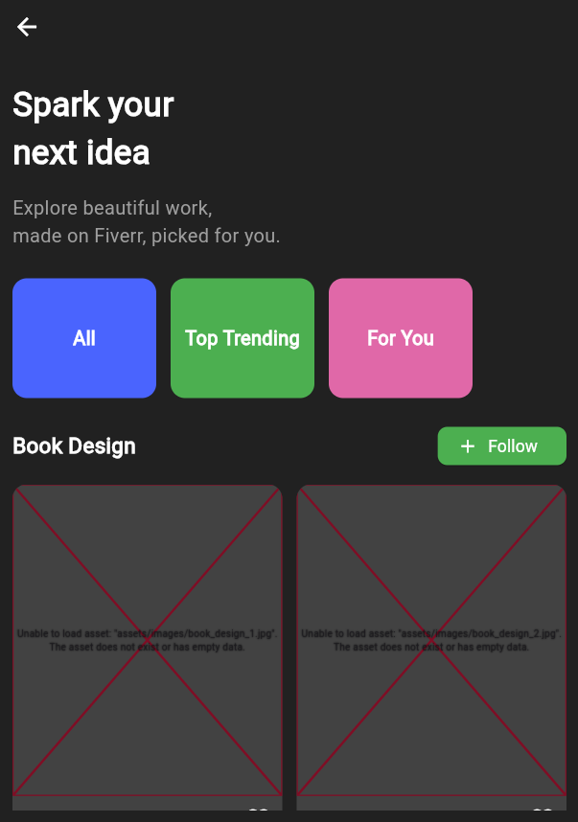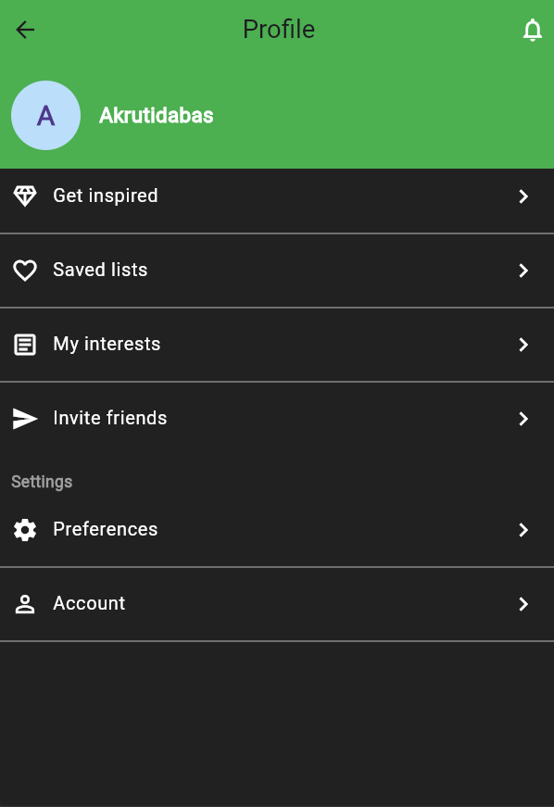**OUTPUT**